**Biology Study Guide** Unit Cell Division

**Vocabulary**

*Give a brief definition of each of these terms. These words are likely to be used on the exam.*

1. Somatic Cell –
2. Gametic Cell –
3. Chromatin –
4. Chromosomes –
5. Mitosis –
6. Chromatids –
7. Centromere -
8. Daughter Chromosomes –
9. Cytokinesis –
10. Diploid –
11. Haploid –
12. Meiosis –
13. Homologous Chromosomes –
14. Crossing Over -

**Critical Thinking Questions**

1. Keeping the terms chromatin, chromosomes, chromatids, and centromere straight can be very difficult. Draw a chromosome with two sister chromatids joined by a centromere. Label each.
2. What stage would a cell with chromatin and a nucleolus be in?
3. When would the chromatids separate and become daughter chromosomes?
4. Each of the letters below indicates interphase or one of the four phases of mitosis. Identify each.

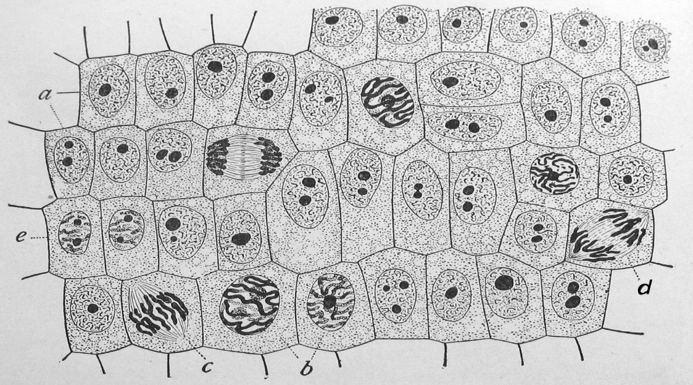

1. Which stage is the most represented in this illustration?
2. What is the diploid number of chromosomes for a human? What is the haploid number?
3. Describe what occurs in the cell during each of the three parts of interphase:
   1. G1 –
   2. S –
   3. G2-
4. Verbally describe the changes that occur in the cell during each phase of mitosis:
   1. Prophase –
   2. Metaphase –
   3. Anaphase –
   4. Telophase –
5. What is the role of the centrioles during mitosis?
6. What occurs during cytokinesis?
7. What are the male and female gametes?
8. 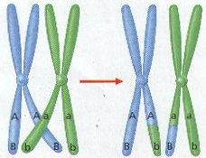A unique part of meiosis I is crossing over. Use this illustration to explain what happens. What stage does it occur, and what is the end result?
9. This diagram shows all the stages of meiosis of sperm. Label meiosis I and meiosis II. Label the individual stages of meiosis I. Label the point at which crossing over occurs. Label each stage with either diploid (2n) or haploid (n) notation.

